**Assignment 7 (Continuous Distributions)**

**EXERCISE 1.**Create a **Standard Normal Distribution Table** using Python *scipy.stats*.

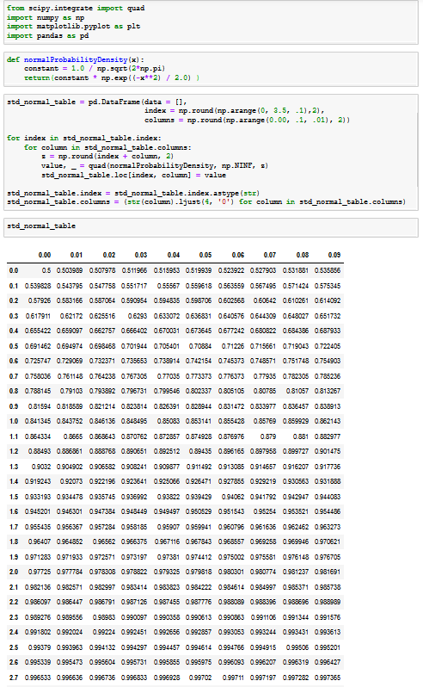

**EXERCISE 2.**

The cycle time for trucks hauling concrete to a highway construction site is uniformly distributed over the interval 50 to 70 minutes. What is the probability that the cycle time exceeds 65 minutes  if it is known that the cycle time exceeds 55 minutes?

mean is μ = 60 STD is $σ=\sqrt{\frac{{(b-a)}^{2}}{12}}=\sqrt{\frac{{(70-50)}^{2}}{12}}=5.77$

for 65, $z= \frac{x-µ}{σ}=\frac{65-60}{5.77}=0.867$ P(65) = 0.80785

for 55, $z= \frac{x-µ}{σ}=\frac{55-60}{5.77}=-0.867$ P(55) = 0.19215

probability that duration > 55, P(>55) = 1-P(55) = 1 – 0.19215 = 0.80785

This is a conditional probability case. $P\left(B | A\right)=\frac{P(A and B)}{P(A)}$

The duration exceeds 55 minutes, and it must exceed 65 minutes (according to the problem), so the duration of intersection is between 65 and 70.

P(between 65 and 70) = 1 – P(65) = 1 – 0.80785 = 0.19215

$$P\left(65 | 55\right)=(P(65 and 55))/(P(>55))$$

$$P\left(65 | 55\right)=(P(65 and 55))/(P(>55))$$

$$P\left(65 | 55\right)=\frac{0.19215}{0.80785}=0.238$$

**EXERCISE 3.**The width of bolts of fabric is normally distributed with mean 950 mm (millimeters) and standard deviation 10 mm.

**1.** What is the probability that a randomly chosen bolt has a width of between 947 and 958mm?

$z=\frac{x-μ}{σ}=\frac{947-950}{10}=-0.3$ for the bolts of diameter 947 mm

$z=\frac{x-μ}{σ}=\frac{958-950}{10}=0.8$ for the bolts of diameter 958 mm

probability will be: P958 – P947 = (0.78814) – (0.38209) = 0.40605

The answer is, a randomly chosen bolt, having a diameter between 947 and 958 mm, is a probability of

% 40.605.

**2.** What is the appropriate value for C such that a randomly chosen bolt has a width less than C with probability .8531?

From the z-table, the z value is 1.05. The equation is:

$$z=\frac{x-μ}{σ}=\frac{C-950}{10}=1.05$$

So, C = 960.5 mm

**EXERCISE 4.**The school board administered an IQ test to 20 randomly selected teachers. They found that the average IQ score was 114 with a standard deviation of 10. Assume that the cumulative probability is 0.90. What population mean would have produced this sample result?

$$μ=114, σ=10, probability=0.90, z-score=1.29$$

$$z=\frac{x-μ}{σ}=1.29=\frac{X-114}{10}$$

X = 126.9